NAME :M.NAVEEN KUMAR REDDY

REG NO :192111719

COURSE :SOFTWARE ENGINEERING

CODE :CSA1001

FACULTY :DR.MARY VALANTINA.G

DATE :29/09/22

**LAB MANUAL 17 TO 25**

**EXPERIMENT:17**

17.Draw and validate the flowchart to compute the quotient and remainder.

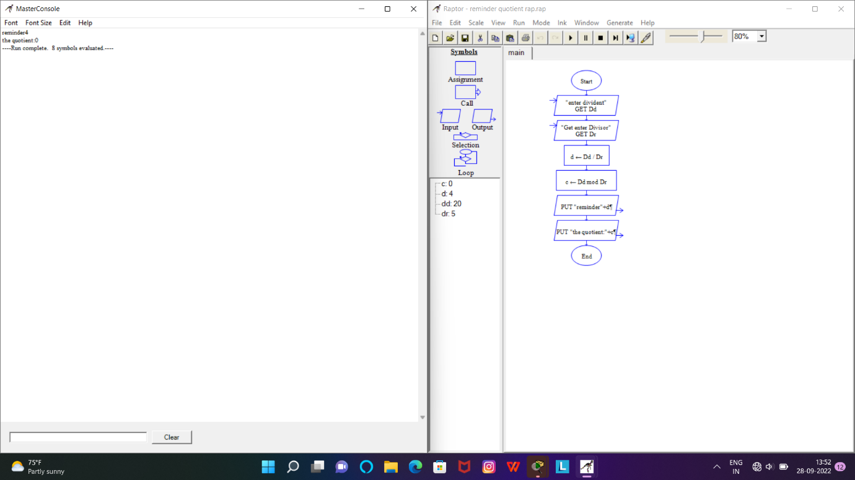

RESULT:Successfully designed this experiment using raptor tool

**EXPERIMENT:18**

18.Using Raptor- Draw and validate the flowchart to calculate Fibonacci series

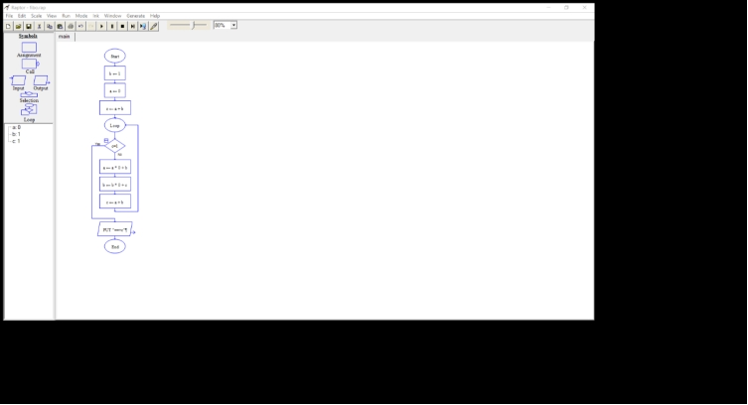

RESULT:Successfully designed this experiment using raptor tool

**EXPERIMENT:20**

20.Using Raptor – Draw and validate the flowchart to swap two characters.

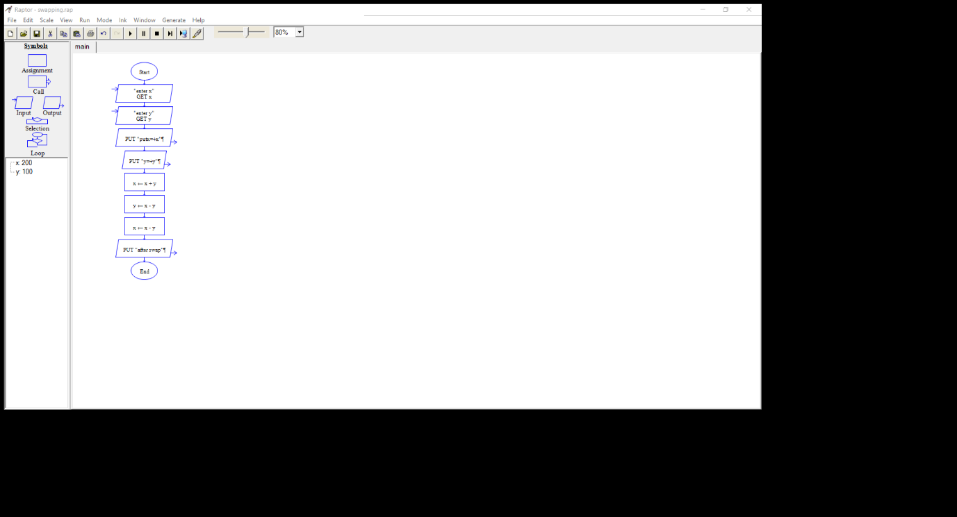

RESULT:Successfully designed this experiment using raptor tool

**EXPERIMENT:21**

21.Using Raptor – Draw the flowchart to display the length of the string.

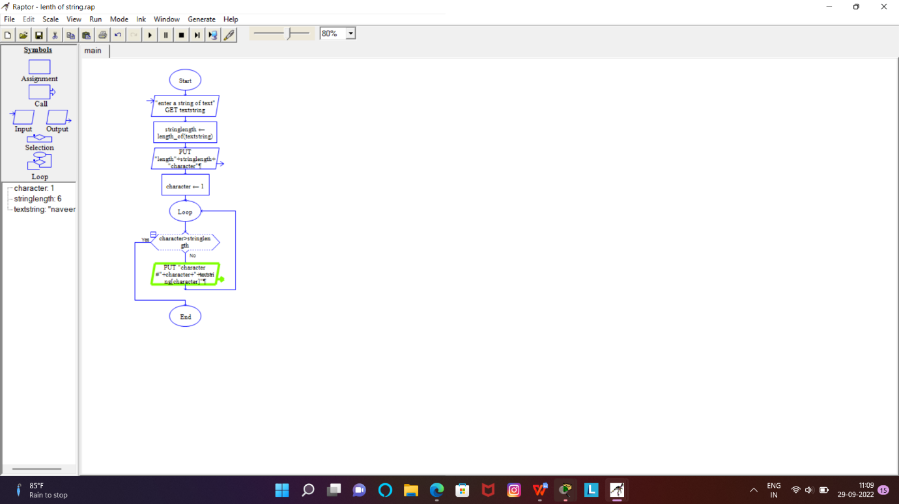

RESULT:Successfully designed this experiment using raptor tool

**EXPERIMENT:22**

22.Using Raptor – Draw the flowchart to find whether the given number is prime or not.

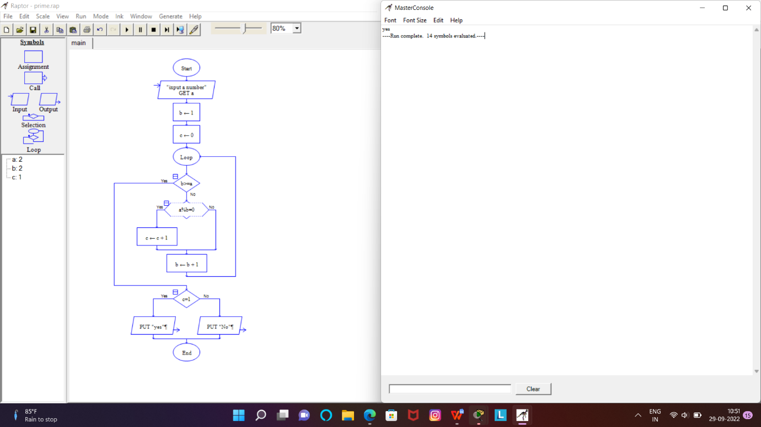

RESULT:Successfully designed this experiment using raptor tool